
Token Launch – Deploying a Token Locally
Objective/Aim:

To learn how to develop and deploy a custom ERC-20 token on a local Hardhat blockchain and examine how smart contracts behave in a test environment.

Apparatus/Software Used:

- Laptop / PC
- App.aave
- Remix IDE
- Metamask
- Etherscan
Theory/Concept:
• ERC-20 Token Standard: A standard for fungible tokens that defines essential functions such as transfer, approve, balanceOf, and others.
• Deployment Options: Local Deployment: Uses a simulated blockchain environment like Ganache or Hardhat for testing purposes.
Testnet Deployment: Uses public Ethereum test networks such as Goerli or Sepolia, funded with test ETH.
• Testnets: Public Ethereum networks that mimic the mainnet’s behavior but use test ETH instead of real cryptocurrency.
• Purpose of Testnets: Developers deploy smart contracts here to simulate real-world scenarios — including gas fees, transaction confirmations, and multi-user interactions — without financial risk.
• Capabilities on Testnets: Testnets allow interaction with wallets (e.g., MetaMask), block explorers (e.g., Etherscan Testnet), and decentralized applications (dApps).
• Avee.net: Provides a web interface for interacting with deployed ERC-20 tokens, allowing users to view balances, execute transfers, and approve spenders.

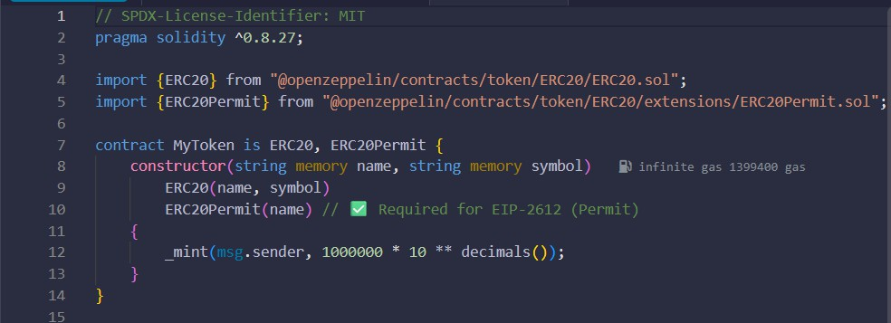
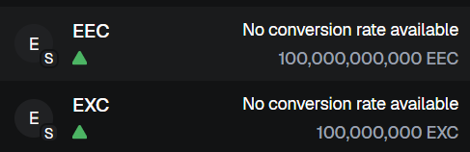
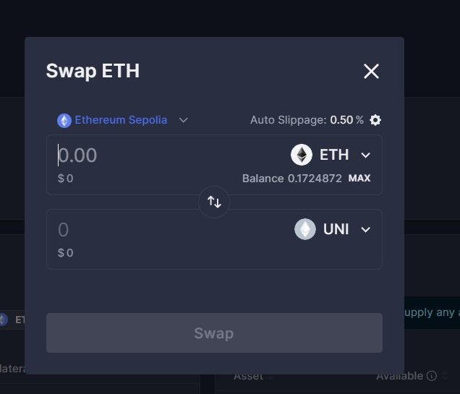
Procedure:
Step 1: Write Token Contract (in Remix IDE)
Step 2: Open Remix IDE → Select compiler 0.8.x → Compile MyToken.sol. Step 3: Deploy Token
- In Remix → “Deploy & Run Transactions” tab.
- Select Injected Web3 (MetaMask connected to local testnet). Step 4: Verify on Avee.net
- Copy deployed contract address.
- Go to Avee.net → Add Token → Paste contract address.
- Token appears in the dashboard.
Step 5: Interact with Token
  - Check total supply.
  - Transfer tokens between MetaMask accounts.
  - Use Avee.net to approve and transfer tokens on behalf of another account.

contract

Token

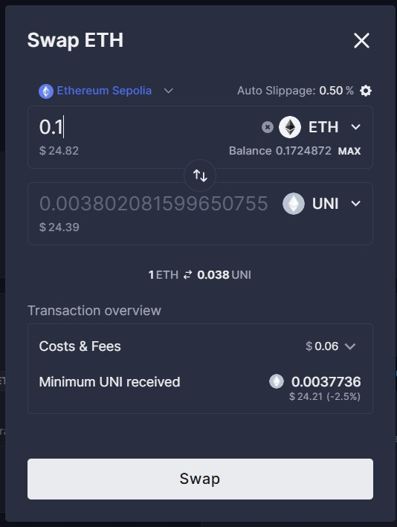
Observation
- Token contract deployed successfully.
- Contract address was visible and verified through Avee.net.
- Initial supply was credited to the deployer’s wallet (MetaMask).
- Able to transfer tokens and check balances on Avee.net interface.

